**DQN Project Graphs**

**New reward and improved parameters**

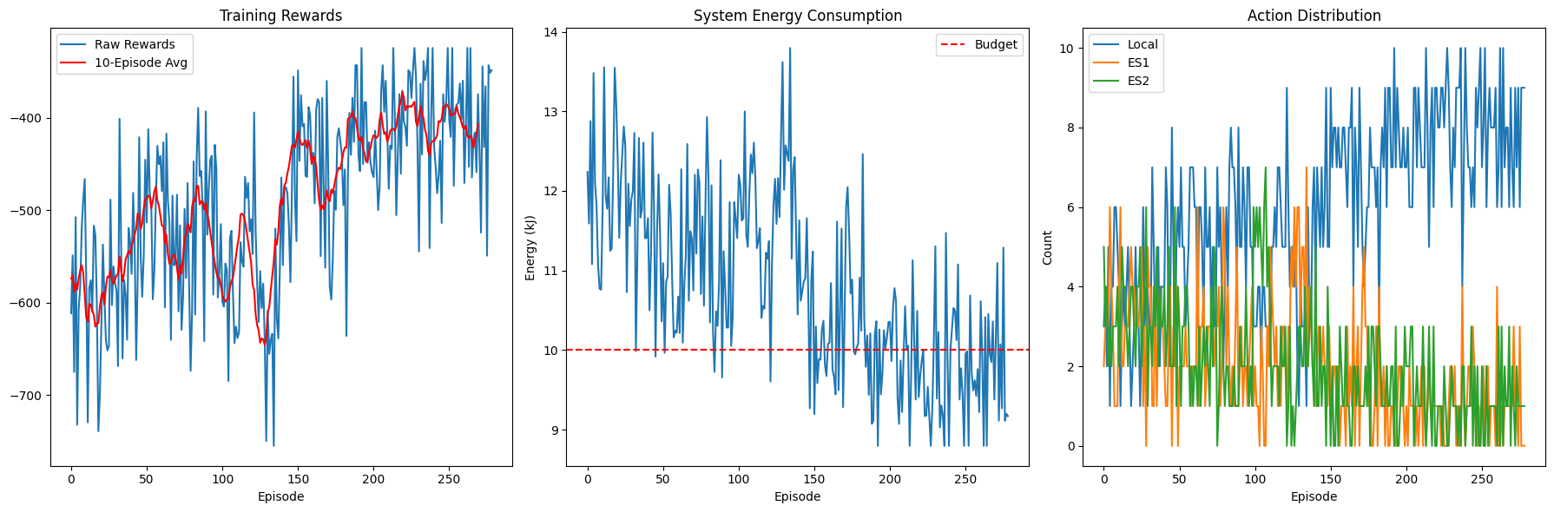

**Let's analyze the energy costs using the formulas from the MECEnvironment class:**

**For Local Processing:**

**energy_needed = (md_energy_local * task_size * 1e9) / (md_compute * 1e9)**

**For Edge Processing:**

**tx_energy = md_energy_tx * task_size * 2.5**

**process_energy = (es_energy_process * task_size * 1e9) / (es_compute * 1e9)**

**total_energy = tx_energy + process_energy**

**250 MB Task Calculations**

| **Parameter** | **Local Processing Range** | **Edge Processing Range** |
| --- | --- | --- |
| **MD Energy Local** | **4.0-10.0 J/GB** | **-** |
| **MD Compute** | **1.5-3.5 GHz** | **-** |
| **MD Energy TX** | **-** | **0.6-1.2 J/MB** |
| **ES Energy Process** | **-** | **35.0-65.0 J/GB** |
| **ES Compute** | **-** | **25.0-35.0 GHz** |

**Local Energy:**

**Min: (4.0 * 250) / 3.5 = 285.7 J**

**Max: (10.0 * 250) / 1.5 = 1666.7 J**

**Edge Energy:**

**TX Min: 0.6 * 250 * 2.5 = 375 J**

**TX Max: 1.2 * 250 * 2.5 = 750 J**

**Processing Min: (35.0 * 250) / 35.0 = 250 J**

**Processing Max: (65.0 * 250) / 25.0 = 650 J**

**Total Min: 375 + 250 = 625 J**

**Total Max: 750 + 650 = 1400 J**

**10 MB Task Calculations**

**Local Energy:**

**Min: (4.0 * 10) / 3.5 = 11.4 J**

**Max: (10.0 * 10) / 1.5 = 66.7 J**

**Edge Energy:**

**TX Min: 0.6 * 10 * 2.5 = 15 J**

**TX Max: 1.2 * 10 * 2.5 = 30 J**

**Processing Min: (35.0 * 10) / 35.0 = 10 J**

**Processing Max: (65.0 * 10) / 25.0 = 26 J**

**Total Min: 15 + 10 = 25 J**

**Total Max: 30 + 26 = 56 J**

**Energy Comparison Table**

| **Task Size** | **Processing Type** | **Min Energy (J)** | **Max Energy (J)** |
| --- | --- | --- | --- |
| **250 MB** | **Local** | **285.7** | **1666.7** |
| **250 MB** | **Edge** | **625.0** | **1400.0** |
| **10 MB** | **Local** | **11.4** | **66.7** |
| **10 MB** | **Edge** | **25.0** | **56.0** |

**Key Observations:**

1. **Small tasks (10MB) are more energy-efficient to process locally**
2. **Medium tasks (250MB) show complex tradeoffs:**
   * **Edge processing has higher minimum energy but more predictable costs**
   * **Local processing can be more efficient for high-performance MDs**
3. **Energy costs scale super-linearly with task size due to:**
   * **Transmission energy multiplier (2.5×)**
   * **Processing energy's inverse relationship with compute speed**

**This explains why the agent needs to learn context-aware offloading strategies based on device capabilities and current battery states.**

**The hyperparameter sets are as follows:**

**HP_CONFIGS = {**

**"conservative": {**

**'memory_size': 50000,**

**'batch_size': 128,**

**'gamma': 0.95,**

**'epsilon_decay': 0.98,**

**'epsilon_min': 0.1,**

**'learning_rate': 0.001,**

**'tau': 0.1,**

**'network_layers': [128, 64],**

**'energy_penalty_scale': 0.002,**

**'prioritization_beta': 0.5**

**},**

**"aggressive": {**

**'memory_size': 200000,**

**'batch_size': 512,**

**'gamma': 0.99,**

**'epsilon_decay': 0.99,**

**'epsilon_min': 0.2,**

**'learning_rate': 0.0003,**

**'tau': 0.05,**

**'network_layers': [512, 256],**

**'efficiency_bonus': 3.0,**

**'task_reward': 10.0**

**},**

**"balanced": {**

**'memory_size': 100000,**

**'batch_size': 256,**

**'gamma': 0.97,**

**'epsilon_decay': 0.995,**

**'epsilon_min': 0.05,**

**'learning_rate': 0.0005,**

**'tau': 0.12,**

**'network_layers': [256, 128],**

**'energy_penalty_scale': 0.0015,**

**'budget_penalty': 12.0**

**},**

**"hp6": {**

**'memory_size': 30000,**

**'batch_size': 64,**

**'gamma': 0.93,**

**'epsilon_decay': 0.97,**

**'epsilon_min': 0.2,**

**'learning_rate': 0.002,**

**'tau': 0.25,**

**'network_layers': [64, 32],**

**'energy_penalty_scale': 0.001,  # Reduced penalty**

**'reward_components': {**

**'task': 9.0,**

**'efficiency': 1.5,**

**'budget': 8.0**

**}**

**},**

**"hp5": {**

**'memory_size': 150000,**

**'batch_size': 384,**

**'gamma': 0.98,**

**'epsilon_decay': 0.998,  # Slower exploration decay**

**'epsilon_min': 0.15,**

**'learning_rate': 0.0002,**

**'tau': 0.08,**

**'network_layers': [512, 256, 128],**

**'prioritization_alpha': 0.7,  # More aggressive prioritization**

**'prioritization_beta': 0.5**

**},**

**"hp4": {**

**'memory_size': 75000,**

**'batch_size': 192,**

**'gamma': 0.96,**

**'epsilon_decay': 0.985,**

**'epsilon_min': 0.05,**

**'learning_rate': 0.0007,**

**'tau': 0.15,**

**'task_reward': 10.0,  # Higher task completion reward**

**'efficiency_bonus': 3.0,**

**'network_layers': [384, 192]**

**}**

**}**

**Hyperparameter Tuning  
  
  
  
  
(i) Set A(Conservative)**

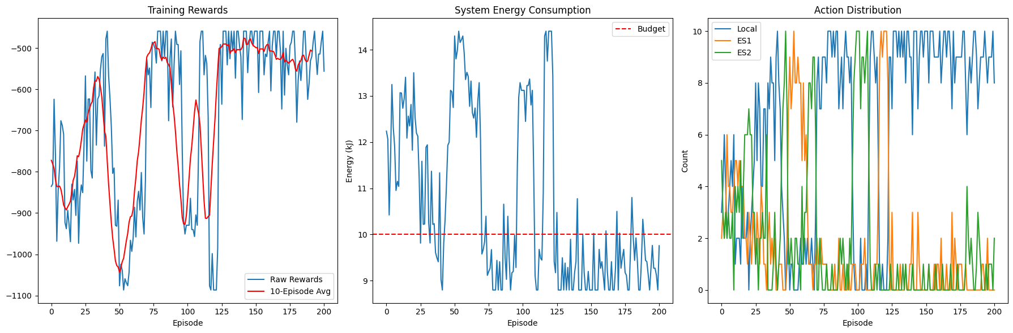

**(ii)Set B(Aggressive)**

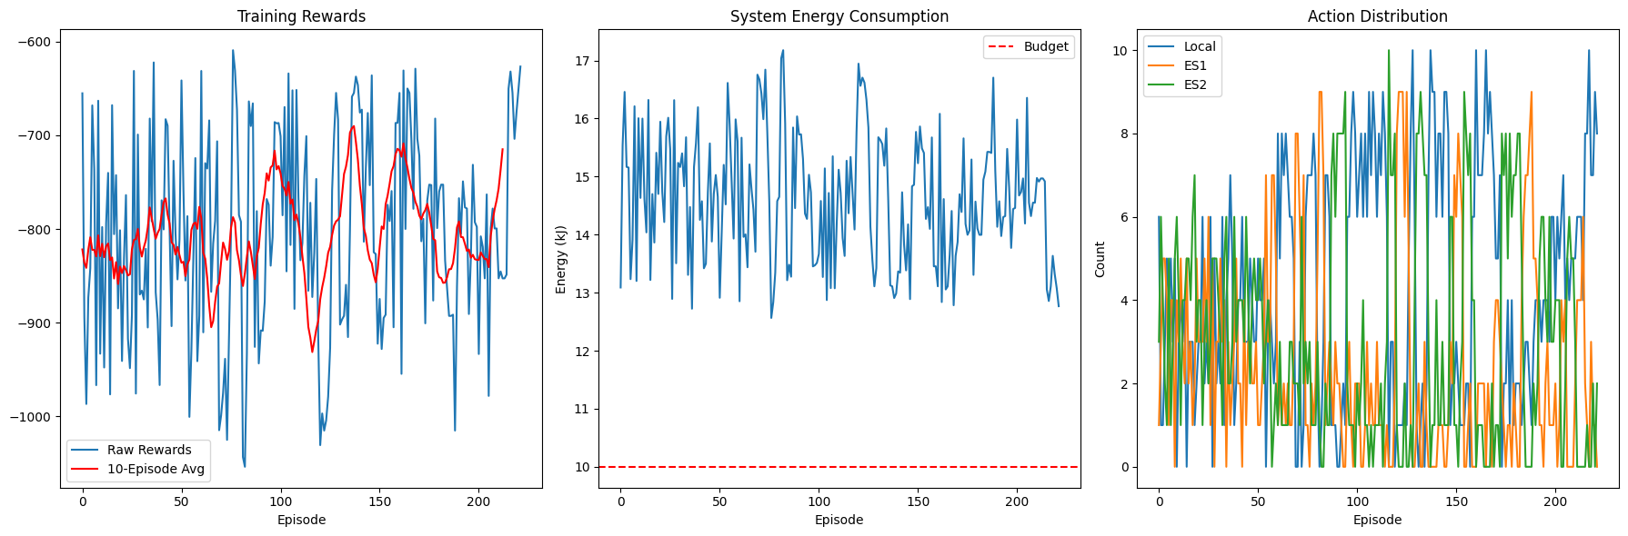

**(iii)Set c(balanced)**

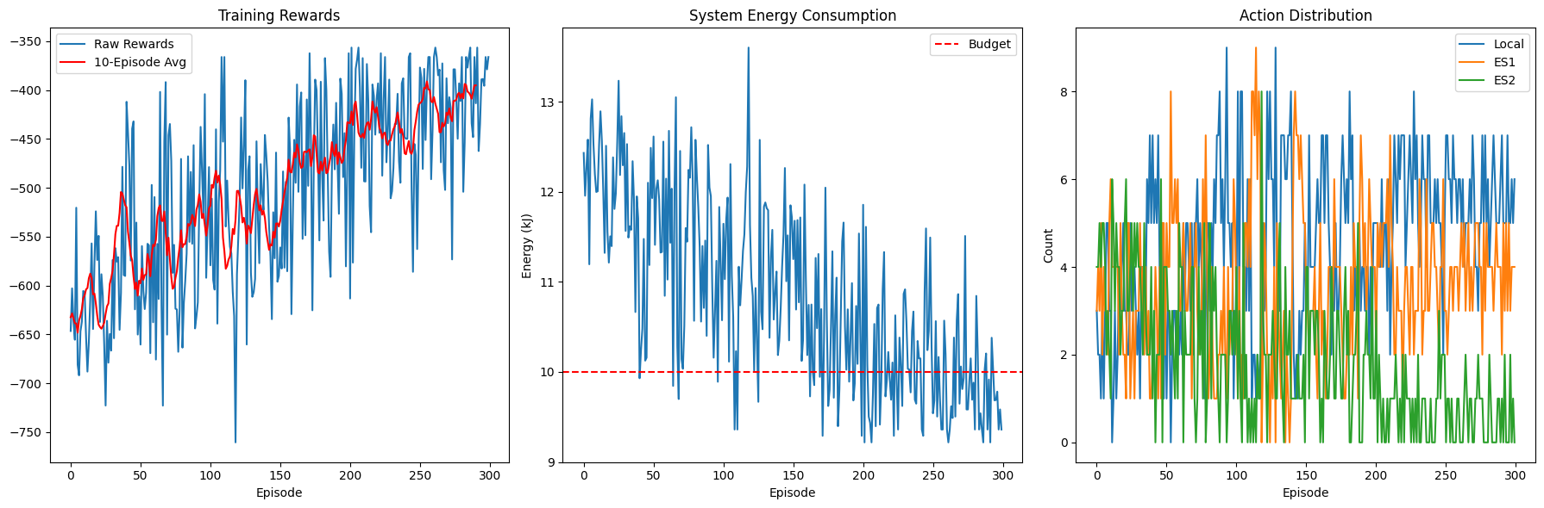

**(iv)Hp 6**

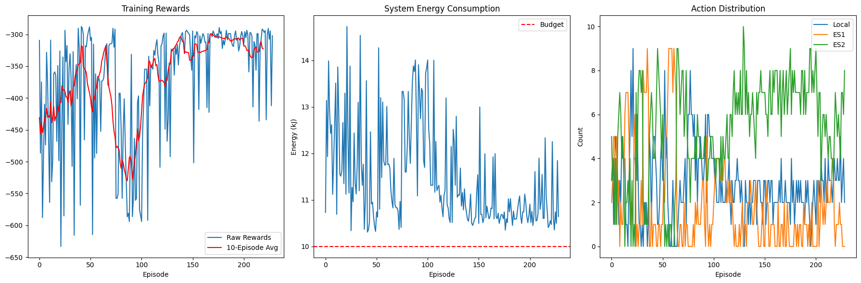

**(v)Hp 5**

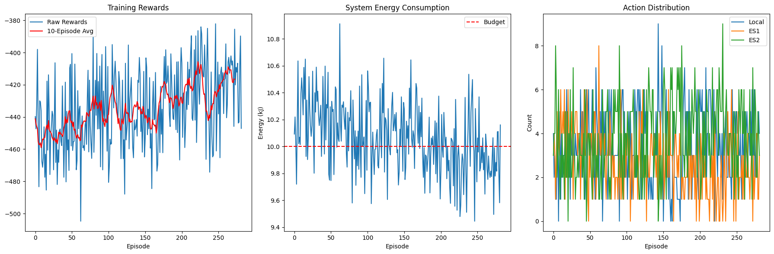

**(vi)Hp 6**

**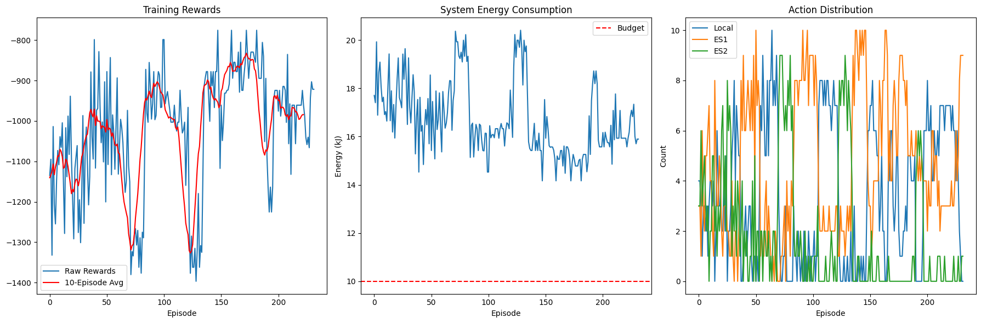  
  
  
The best results were seen in the balanced hyperparameter set.**

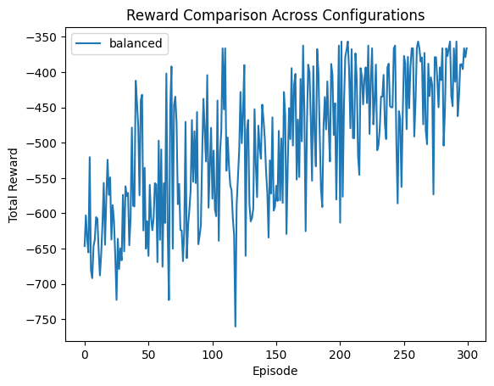

**New Model with few files(10)**

**(i)Learning rate =0.0005**

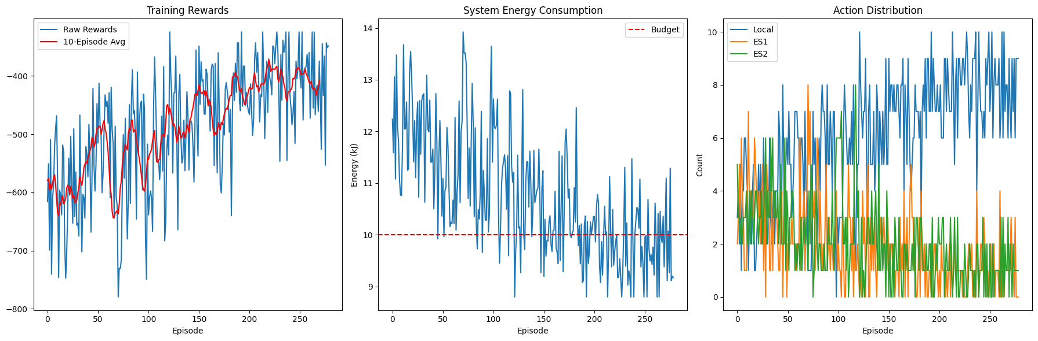

**(ii)Learning rate =0.0001**

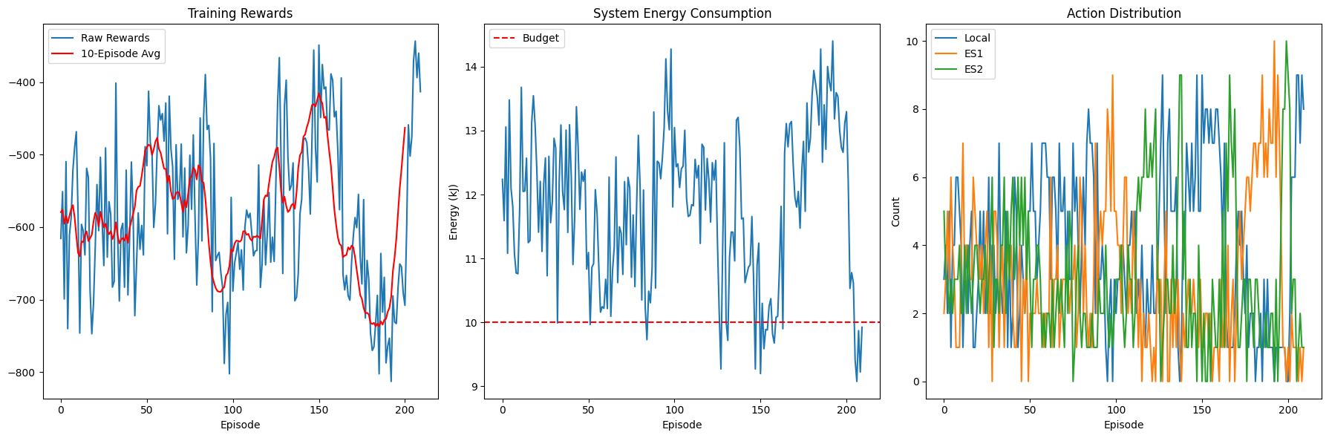

**New model in different Environments**

**(i)md=3,es=2,num_tasks=10**



**(ii)md=4,es=1,num_tasks=20**

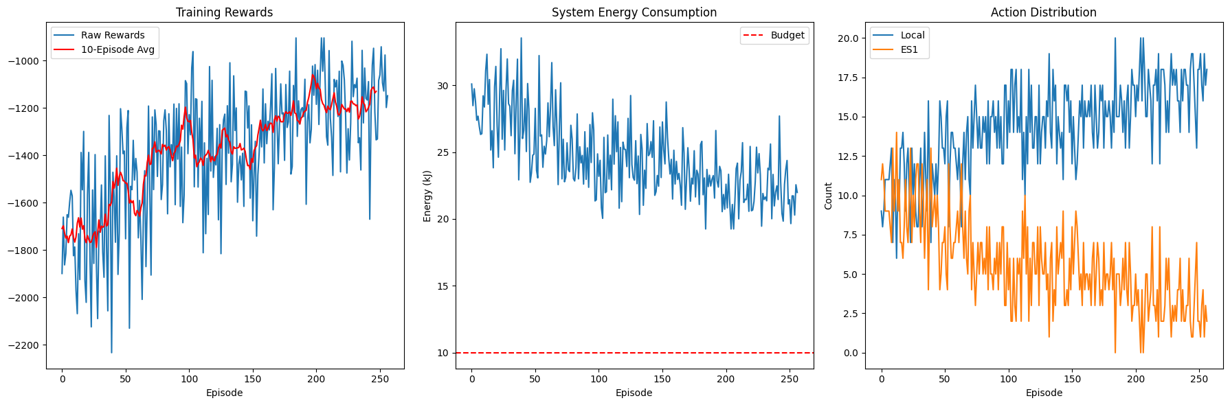

(iii)md=10,es=4,num_tasks=50

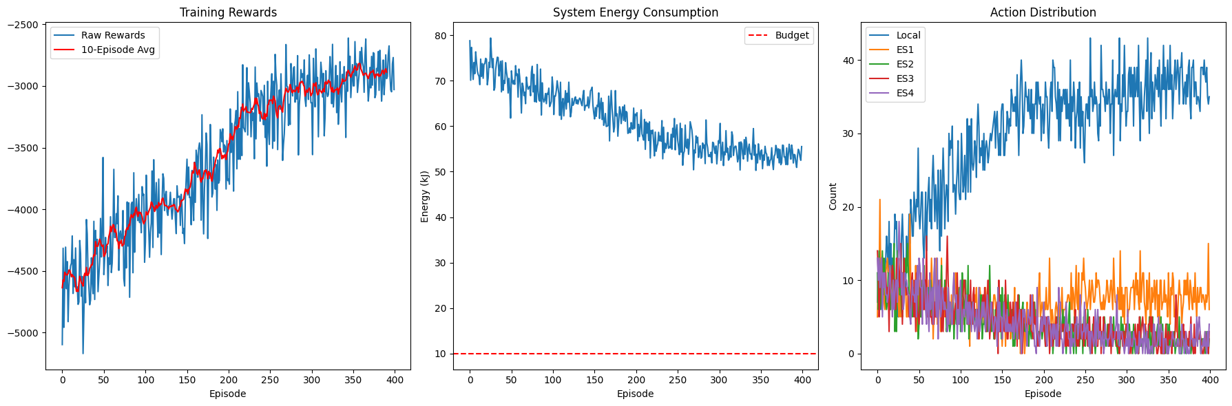

**Traditional Model**

(i)md=3,es=2,num_tasks=10

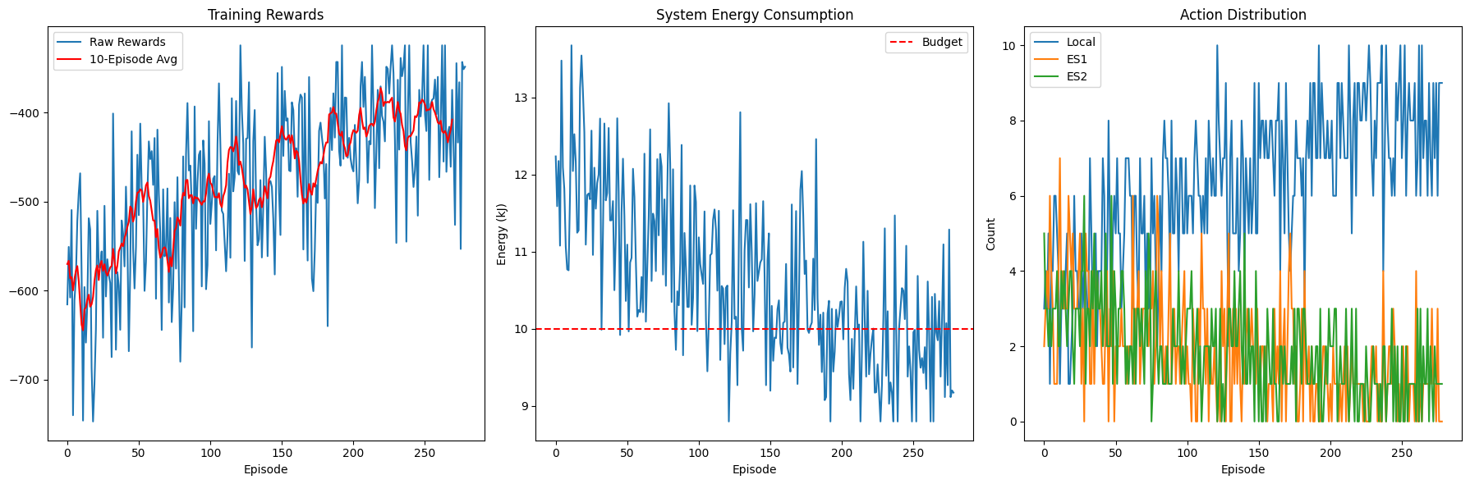

(ii)md=4,es=1,num_tasks=20

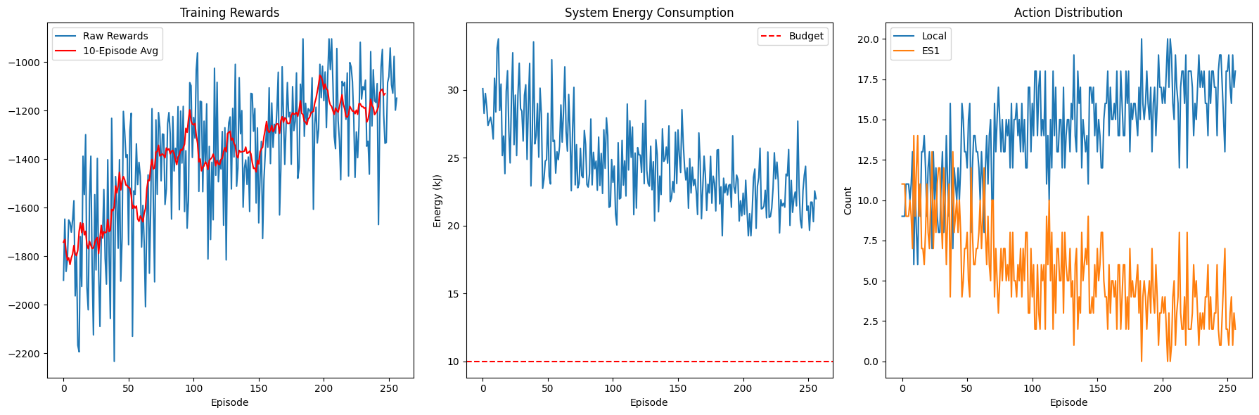

(iii)md=10,es=4,num_tasks=50

